UNITED STATES HISTORY
SECTION I
Time—55 minutes
80 Questions

Directions: Each of the questions or incomplete statements below is followed by five suggested answers or completions. Select the one that is best in each case and then fill in the corresponding oval on the answer sheet.

1. The Navigation Acts were part of the British policy known as

(A) isolationism
(B) capitalism
(C) mercantilism
(D) monopolism
(E) imperialism

2. Jacksonian Democracy was distinguished by the belief that

(A) an aristocracy posed no danger to the Republic
(B) the National Republicans alone knew what was right for the people
(C) political participation by the common man should be increased
(D) political rights should be granted to women
(E) franchise restrictions should be racially neutral

3. President Monroe articulated the Monroe Doctrine in his 1823 address to Congress primarily in order to

(A) respond positively to the recent Latin American revolutions
(B) rule out United States involvement in South America
(C) provide a rationale for United States intervention in the Isthmus of Panama
(D) warn European nations against further colonial ventures in the Western Hemisphere
(E) encourage Britain to help the fledgling Latin American states

4. Which of the following transportation developments opened the West to settlement and trade between 1790 and 1830?

(A) Turnpikes and canals
(B) Railroads and steamships
(C) Turnpikes and railroads
(D) Clipper ships and turnpikes
(E) Canals and railroads

5. Which of the following best describes the situation of freedmen in the decade following the Civil War?

(A) Each was given 40 acres of land and a mule by the Union government.
(B) All were immediately granted political equality by the Emancipation Proclamation.
(C) The majority entered sharecropping arrangements with former masters or other nearby planters.
(D) They were required to pass a literacy test before being granted United States citizenship.
(E) They supported the passage of Black Codes to ensure their economic and political rights.

6. Which of the following was a serious constitutional question after the Civil War?

(A) The restoration of the power of the federal judiciary
(B) The legality of the national banking system
(C) The political and legal status of the former Confederate states
(D) The relationship between the United States and Britain
(E) The proposed annexation of Colombia

7. The Supreme Court decision in Plessy v. Ferguson (1896) did which of the following?
(A) Denounced business combinations in restraint of trade.
(B) Sanctioned separate but equal public facilities for African Americans.
(C) Declared that the Fourteenth Amendment applied principally to the protection of corporations.
(D) Defined the Constitution as color-blind.
(E) Empowered Congress to cancel treaties with American Indian tribes unilaterally.

8. The flappers of the 1920’s challenged traditional American attitudes about women by supporting

(A) a federal birth control and abortion rights protection law
(B) gender equality in salaries
(C) an equal rights amendment
(D) greater freedom in manner of dress and moral behavior
(E) a federal law to establish prenatal clinics in rural areas

9. During the 1930’s, the Great Depression led to

(A) the nationalization of major industries
(B) the strengthening of the family unit and a higher birth rate
(C) a decline in highway construction
(D) a mass internal migration of Americans looking for work
(E) a decrease in labor union membership

10. The policy of containment, justified by George Kennan’s 1947 analysis of the international situation, called for

(A) blocking the expansion of the Soviet Union’s influence
(B) curbing United States foreign investment to limit involvement in world conflict
(C) liberating Eastern Europe from communism
(D) destabilizing the Soviet Union
(E) dividing Germany into zones administered by the United States, Britain, and the Soviet Union

11. The Dutch settled New Netherland primarily to

(A) secure a refuge for the persecuted
(B) check the growth of English colonies in North America
(C) expand their commercial and mercantile network
(D) gain colonies to produce agricultural surpluses
(E) secure naval supplies

12. France negotiated a treaty of alliance with the new American nation in 1778 following

(A) the defeat of the British General Burgoyne at Saratoga
(B) American naval victories on the Great Lakes
(C) the dispatch of an American peace mission to Britain
(D) an ultimatum by American diplomats
(E) a personal plea by George Washington

13. Which of the following is true of the case of Marbury v. Madison?

(A) It established that Congress had the sole right to formulate national legislation.
(B) It supported Thomas Jefferson in his claim to have “executive review.”
(C) It backed William Marbury in his request for a bank charter.
(D) It affirmed the principle of judicial review.
(E) It determined the Senate’s right to “advise and consent.”

14. After the Revolution, the concept of the “republican mother” suggested that

(A) women would be responsible for raising their children, especially their sons, to be virtuous citizens of the young republic
(B) voting would soon become a privilege granted to educated and/or married women
(C) the first duty of mothers was to serve the needs of government
(D) wives and mothers would be welcome in the emerging political parties
(E) women’s virtues had been the inspiration for the ideals of the Revolution

15. All of the following accurately describe Jefferson’s purchase of the Louisiana Territory from France EXCEPT:

(A) It opened the Mississippi River permanently to western farmers.
(B) It ended the threat of American Indian raids on western settlements.
(C) It was made possible by the failure of Napoleon’s forces to suppress a slave revolt in Haiti.
(D) It showed Jefferson’s considerable flexibility in dealing with foreign policy.
(E) It violated Jefferson’s own views concerning the strict construction of the Constitution.

16. President Jackson resisted the admission of Texas into the Union in 1836 primarily because he

(A) acknowledged the legitimacy of the Mexican government’s claim to Texas
(B) feared that debate over the admission of Texas would ignite controversy about slavery
(C) was ideologically opposed to territorial expansion
(D) could find no support within his own party for admitting Texas
(E) believed that admitting Texas would violate international law

17. The Republican party originated in the mid-1850’s as a sectional party committed to which of the following?

(A) Opposition to the further extension of slavery into the territories
(B) Immediate emancipation of the slaves
(C) Repeal of Whig economic policies
(D) Restriction of immigration
(E) Acknowledgement of popular sovereignty as the basis for organizing federal territories

18. In 1890 the most important source of revenue for the federal government was

(A) income taxes
(B) inheritance taxes
(C) sales taxes
(D) liquor taxes
(E) customs duties

19. William Jennings Bryan’s “Cross of Gold” oration was primarily an expression of his

(A) fundamentalist religious beliefs
(B) neutral stance toward the belligerents of the First World War
(C) advocacy of free and unlimited coinage of silver
(D) opposition to teaching the theory of evolution in public schools
(E) anti-imperialist convictions

20. The American home front in the Second World War is best described as

(A) politically divided over the wisdom of the American war effort
(B) unaffected by ethnic and racial tensions
(C) economically invigorated by military spending
(D) rededicated to the reform efforts of the New Deal
(E) demoralized by food shortages

21. In which of the following British North American colonies was slavery legally established by the early 1700’s?

(A) The southern colonies only
(B) The middle and southern colonies only
(C) The tobacco- and rice-growing colonies only
(D) All the colonies except Pennsylvania and the New England colonies
(E) All the colonies

22. In the United States, the Haitian rebellion of the 1790’s prompted
(A) the acquisition of Puerto Rico for colonization by emancipated slaves
(B) a movement of free African Americans to Haiti
(C) the passage of a federal law increasing the severity of punishments for slave rebellions
(D) an increased fear of slave revolts in the South
(E) a military expedition of southern slaveholders to restore French rule in Haiti

23. Which of the following statements about African American soldiers during the Civil War is correct?

(A) They were primarily engaged in military campaigns west of the Mississippi.
(B) They were limited to noncombat duty.
(C) They were barred from receiving awards for valor in combat.
(D) For most of the war, they were paid less than White soldiers of equal rank.
(E) For most of the war, they were led by African American officers.

24. The Strategic Arms Limitations Talks (SALT), expanded trade with the Soviet Union, and President Richard Nixon’s visit to the People’s Republic of China were all facets of the policy of

(A) brinkmanship
(B) deterrence
(C) détente
(D) rollback
(E) liberation

25. All of the following contributed to the passage of the Eighteenth Amendment legislating Prohibition in 1919 EXCEPT

(A) the continued efforts of the Anti-Saloon League
(B) the fervor of the First World War lending patriotism to the cause of prohibition
(C) the Progressive belief in social reform
(D) the cumulative impact of state prohibition laws
(E) the high death toll from alcohol-related automobile accidents

26. In the decade following the Second World War, the Supreme Court decision that had the most widespread consequences concerned which of the following?

(A) Immigration policy
(B) Congressional reapportionment
(C) The rights of minority groups
(D) The jurisdiction of courts in determining war guilt
(E) The federal government’s powers of taxation

27. Prior to the Civil War, a transformation occurred in the workforce of the New England textile mills as New England farm girls were replaced by

(A) French-Canadian immigrants
(B) freed African Americans from the South
(C) Irish immigrants
(D) German immigrants
(E) Italian immigrants

28. The primary power granted to the Civil Rights Commission created in 1957 was the authority to

(A) investigate and report on cases involving discrimination
(B) issue writs to enforce its decisions after a hearing
(C) initiate court cases to challenge gender discrimination
(D) fine employers found guilty of discriminatory hiring practices
(E) grant monetary awards to victims of discrimination

29. During his presidency, Richard Nixon did which of the following?

(A) Supported the use of busing to end racial segregation in public schools.
(B) Intensified conflict between the United States and Japan.
(C) Abolished the Tennessee Valley Authority.
(D) Ended American participation in the war in Vietnam.
(E) Created the National Aeronautics and Space Administration.

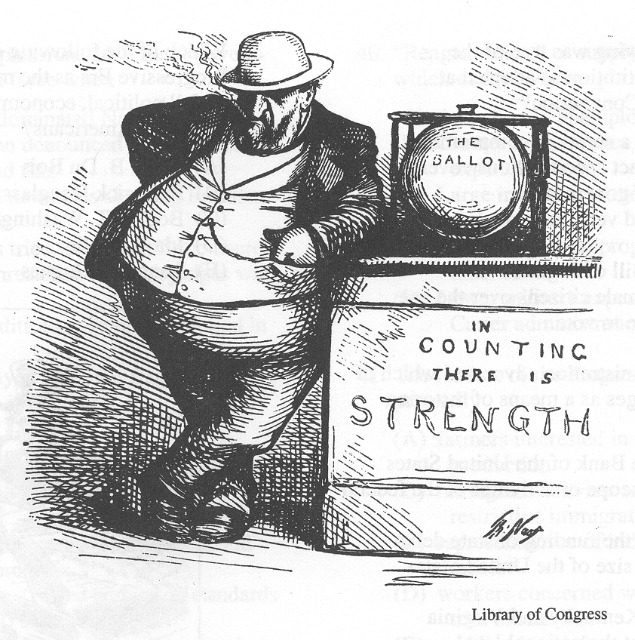
30. The cartoon above is a commentary on late-nineteenth-century

(A) municipal corruption
(B) imperialism
(C) labor unrest
(D) business monopolies
(E) civil-rights campaigns

31. Which of the following was true of the United States Constitution as adopted at the Constitutional Convention?

(A) It was built on a series of compromises.
(B) It provided exact specifications covering all aspects of government.
(C) It was a revised version of the English Constitution.
(D) It included a Bill of Rights.
(E) It allowed all male citizens over the age of twenty-one to vote.

32. The Jefferson administration advocated which of the following changes as a means of restoring republican ideals?

(A) Abolishing the Bank of the United States
(B) Reducing the scope of activities of the federal government
(C) Discontinuing the funding of state debts
(D) Increasing the size of the United States military
(E) Adopting the Kentucky and Virginia Resolutions at the national level

33. The Wilmot Proviso specifically provided for

(A) the prohibition of slavery in Louisiana Purchase territory
(B) the primacy of federal law over state legislated Black Codes
(C) the abolition of the international slave trade
(D) the prohibition of slavery in lands acquired from Mexico in the Mexican War
(E) federal return of fugitive slaves

34. The Roosevelt Corollary to the Monroe Doctrine expanded America’s role in
(A) Central America and the Caribbean
(B) the Philippines
(C) North Africa
(D) Asia
(E) Europe

35. Which of the following emerged during the Progressive Era as the most influential advocate of full political, economic, and social equality for Black Americans?

(A) W. E. B. DuBois
(B) Frederick Douglass
(C) Booker T. Washington
(D) Ida B. Wells
(E) Langston Hughes

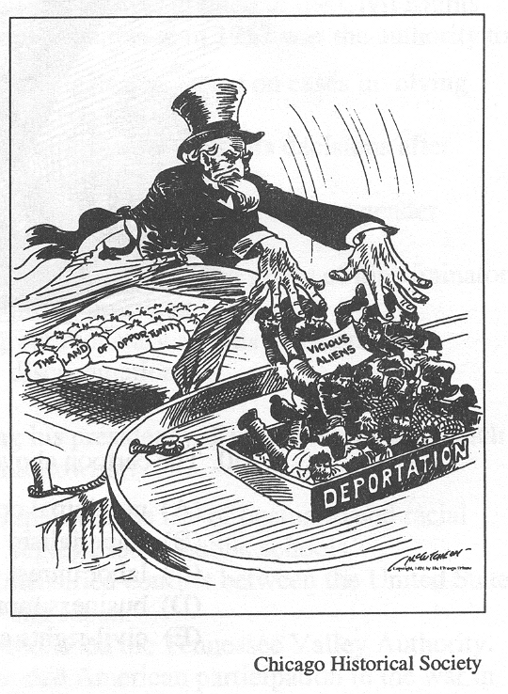
36. The cartoon above refers to which of the following?

(A) The Red Scare
(B) The Open Door Notes
(C) The Immigration Quota Act of 1921
(D) The response to the Pullman Strike
(E) The Boston Police Strike

37. During the Great Depression, the federal government responded with force when

(A) the communist-dominated National Mine Workers’ Union denounced the American government and flag
(B) audiences booed newsreels showing President Herbert Hoover
(C) mobs of farmers tried to prevent foreclosures on farms and threatened to lynch judges who allowed them
(D) the Bonus Expeditionary Force encamped in Washington
(E) protesters displayed “Hoover flags,” empty pockets turned inside out

38. Which of the following is a correct statement about college–level education in the twentieth–century United States?

(A) State universities increased scholarship aid during the Depression.
(B) Private universities raised admission standards during the 1940’s.
(C) The GI Bill financed the education of male students during the post-Second World War era.
(D) The “baby boomers” finished college in large numbers in the 1950’s.
(E) There was a sharp decline in college enrollment during the Vietnam War.

39. “The problem lay buried, unspoken, for many years in the minds of American women. It was a strange stirring, a sense of dissatisfaction, a yearning that women suffered…. Each suburban wife struggled with it alone. As she made the beds, shopped for groceries, matched slipcover material, ate peanut butter sandwiches with her children, chauffeured Cub Scouts and Brownies, lay beside her husband at night-she was afraid to ask even of herself the silent question—‘Is this all?’”

The author of the statement above most likely was

(A) Angelina Grimke
(B) Susan B. Anthony
(C) Betty Friedan
(D) Angela Davis
(E) Phyllis Schlafly

40. “Reaganomics,” or supply-side economics, led to which of the following?

(A) A decline in unemployment and poverty
(B) Greater tax revenues than government expenditures
(C) Large increases in the incomes of wealthy Americans
(D) An increase in appropriations for school lunches
(E) Lower military expenditures than during the Carter administration

41. The leaders of the Progressive movement were primarily

(A) farmers interested in improving agricultural production
(B) immigrant activists attempting to change restrictive immigration laws
(C) representatives of industries seeking higher tariffs
(D) workers concerned with establishing industrial unions
(E) middle-class reformers concerned with urban and consumer issues

42. The majority of White families in the antebellum South owned

(A) more than 100 slaves
(B) 50 to 100 slaves
(C) 10 to 50 slaves
(D) 5 to 10 slaves
(E) no slaves

43. The Missouri Compromise did which of the following?

(A) Prohibited slavery in all the territory of the Louisiana Purchase.
(B) Provided for admission to the Union of all future states in pairs of one free, one slave.
(C) Allowed Maine to enter the Union as a free state.
(D) Finally settled the question of congressional power over slavery in the territories.
(E) Provided for the annexation of Texas.

44. Which of the following best characterizes the writings of American authors F. Scott Fitzgerald, e. e. cummings, and Sinclair Lewis?

(A) Disillusionment with modem American society
(B) Glorification of modem American capitalism
(C) Celebration of Black culture
(D) Glamorization of war
(E) Reaffirmation of traditional American values

45. One of the immediate consequences of the Tet offensive in 1968 was that

(A) President Johnson completed, the process of Vietnamization
(B) North Vietnamese troops took control of Saigon
(C) popular support for the war declined in the United States
(D) the South Vietnamese government was overthrown
(E) Congress gave greater support to President Johnson’s war policies

46. All of the following contributed to discontent among soldiers in the Continental Army EXCEPT:

(A) Most soldiers were draftees.
(B) The soldiers feared for the welfare of families back home.
(C) The army had inadequate arms and ammunition.
(D) The army paid soldiers in depreciated paper money.
(E) The army was inadequately fed and clothed.

47. Jacob Riis’s How the Other Half Lives is a study of

(A) Jim Crow segregation and its effect on African Americans
(B) the plight of Great Plains farmers in the 1890’s
(C) immigrant urban poverty and despair in the 1890’s
(D) the corruption in city political machines in the 1890’s
(E) the rise of industrial capitalists in the late nineteenth century

48. Margaret Sanger is best known for her

(A) contribution to the radical suffragist movement
(B) endorsement of coeducation
(C) advocacy of birth control
(D) presidency of the Women’s Christian Temperance Union
(E) organization of the Women’s Trade Union League

49. The Republican Presidents of the 1920’s favored

(A) membership in the League of Nations
(B) tax cuts for wealthy Americans
(C) stringent federal regulation of American business
(D) reduced American tariffs on foreign imports
(E) forgiveness of European war debts from the First World War

50. From the 1880’s to the beginning of the New Deal, the dominant American Indian policy of the United States government sought to

(A) strengthen traditional tribal authority
(B) relocate all American Indians to the Oklahoma territory
(C) encourage American Indian emigration to Canada
(D) encourage American Indians to preserve their languages and religions
(E) break up tribal landholdings

51. Alexander Hamilton’s financial program was most favorable to

(A) western farmers
(B) war veterans
(C) southern planters
(D) eastern merchants
(E) state bankers

52. The goal of the American Colonization Society was to

(A) return freed slaves to Africa
(B) recruit immigrant labor for American factories
(C) assimilate recent immigrants into American society
(D) extend United States influence to overseas colonies
(E) promote western expansion by funding internal improvements

53. The most unpopular and least successful of President Thomas Jefferson’s policies was his

(A) advocacy of territorial expansion
(B) handling of the Barbary Coast pirates
(C) reduction of the size of the military
(D) reduction of the national debt
(E) adherence to neutrality in dealing with England and France

54. Which of the following principles was established by the Dred Scott decision?

(A) Congress could abolish slavery at will.
(B) National legislation could not limit the spread of slavery in the territories.
(C) The rights of all people are protected by the Constitution.
(D) Slaves residing in a free state automatically became free.
(E) Through squatter sovereignty, a territory had the sole right to determine the status of slavery within its territorial limits.

55. The precipitating factor in the 1894 Pullman strike was Pullman’s

(A) dismissal of union workers
(B) introduction of scrip in part payment of wages
(C) retraction of its promise to provide an employee insurance and retirement plan
(D) employment of immigrant labor at less than a living wage
(E) cutting of wages without proportionate cuts in company housing rents

56. In his Atlanta Compromise speech, Booker T. Washington called for which of the following?

(A) African American voting rights
(B) An end to racial segregation
(C) Support for African American self-help
(D) Educational equality for African Americans
(E) Racial integration of religious organizations

57. All of the following contributed to the growth of the free African American population in the United States in the early nineteenth century EXCEPT

(A) the gradual emancipation laws of individual states
(B) manumission granted for Revolutionary War service
(C) manumission granted by slaveholders’ wills
(D) natural increase among free African Americans
(E) federal constitutional provisions for emancipation

58. In the 1930’s, the movement led by Dr. Francis Townsend contributed to congressional approval of a law

(A) insuring the bank deposits of consumers
(B) securing federal protection of labor union organizers
(C) providing larger federal subsidies to farmers
(D) implementing a federal program of old-age benefits
(E) protecting ethnic minorities from discrimination

59. Which of the following civil rights groups is NOT correctly matched with one of its leading figures?

(A) Southern Christian Leadership Conference. . Marcus Garvey
(B) Black Panthers.. Huey Newton
(C) National Association for the Advancement of Colored People.. Roy Wilkins
(D) Black Muslims.. Malcolm X
(E) Student Nonviolent Coordinating Committee.. Stokely Carmichael

60. Which of the following is true of the Gulf of Tonkin Resolution?

(A) It ended the Vietnam War.
(B) It barely passed in Congress, reflecting the bitter division over American involvement in Vietnam.
(C) It was a statement of American policy that followed the Tet Offensive.
(D) It allowed the President to deploy combat troops in South Vietnam.
(E) It provided for the first peace negotiations between the United States and North Vietnam.

61. The Compromise of 1850 did which of the following?

(A) Admitted Texas to the Union as a slave state.
(B) Admitted California to the Union under the principles of popular sovereignty.
(C) Prohibited slavery in the District of Columbia.
(D) Enacted a stringent fugitive slave law.
(E) Adjusted the Texas-Mexico boundary.

62. One means by which President Hoover attempted to fight the Great Depression was

(A) the establishment of the Tennessee Valley Authority
(B) the establishment of the Reconstruction Finance Corporation
(C) a lowering of barriers to free trade
(D) the early payment of bonuses to veterans
(E) direct government aid to the needy

63. The principal reason for the formation of the Dixiecrat party in 1948 was the opposition of dissident Democrats to President Truman’s

(A) establishment of the Central Intelligence Agency
(B) removal of General MacArthur from his military command
(C) support for the Taft–Hartley Act
(D) proposal for civil rights legislation
(E) call for an investigation of the loyalty of all federal employees

64. Throughout the first half of the nineteenth century, women reformers were most active in the cause of

(A) temperance
(B) woman suffrage
(C) pacifism
(D) immigrants’ rights
(E) workers’ rights

65. Which of the following was true of most Puritans who emigrated to seventeenth-century New England?

(A) They had renounced the Church of England.
(B) They rejected the authority of the English king.
(C) They considered themselves non-Separatists.
(D) They approved of the Crown’s religious policy.
(E) They intended to return eventually to England.

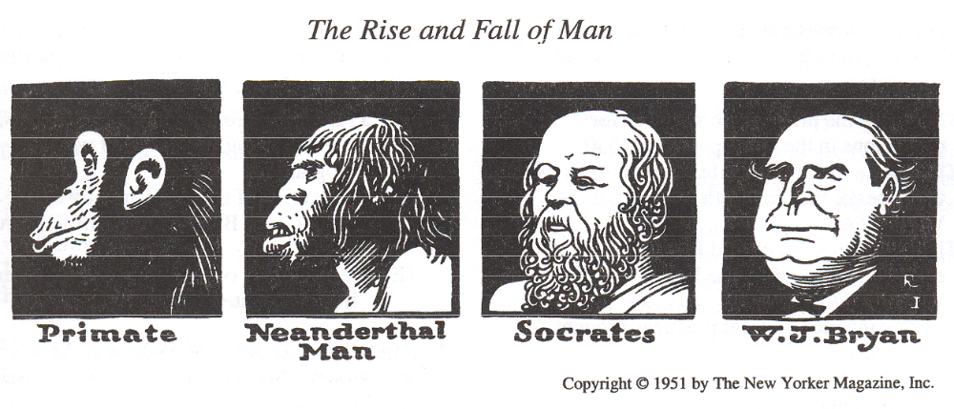
66. The cartoon above was intended primarily as a satirical comment on

(A) Social Darwinism
(B) the Ku Klux Klan
(C) the election of 1896
(D) the Scopes trial
(E) Lochner v. New York

67. The Federalist papers challenged the conventional political wisdom of the eighteenth century when they asserted that

(A) a republican form of government could succeed only in small countries
(B) limitations on the popular will led to tyranny
(C) a weak central government was the only guarantee of individual rights
(D) a large republic offered the best protection of minority rights
(E) political parties were crucial to the success of the new government

68. Wilson’s Fourteen Points incorporated all of the following EXCEPT

(A) open diplomacy
(B) freedom of the seas
(C) recognition of Allied economic and territorial agreements made during the war
(D) creation of an international organization to preserve the peace and security of its members
(E) national self-determination

69. The first massive migration of Black Americans from the South occurred during which of the following periods?

(A) Immediately following the Civil War
(B) During and immediately after the First World War
(C) During the Great Depression
(D) In the decade after the Second World War
(E) During the civil rights movement of the 1960’s

70. In the last quarter of the nineteenth century, American agriculture was characterized by

(A) a decline in the number of tenant farmers
(B) a decline in foreclosures on midwestern farms
(C) a decline in the number of farm cooperatives
(D) an increase in wholesale prices for farm products
(E) an increase in acres under cultivation

71. Which of the following statements about Africans brought as slaves to the British North American colonies is true?

(A) They were the primary labor source for plantations in the Chesapeake by 1630.
(B) They had a much lower life expectancy in the Chesapeake than in South Carolina or the West Indies.
(C) They greatly outnumbered Europeans in every colony south of the Mason-Dixon Line by 1776.
(D) They maintained cultural practices brought from Africa.
(E) They were the primary labor source in Pennsylvania until 1720.

72. Progressive reformers rejected Social Darwinism because they believed that

(A) all races were equal in ability
(B) personal development was influenced solely by hereditary factors
(C) conflict and competition did not necessarily improve society
(D) science had no role in society
(E) society was fixed by the laws of nature and incapable of significant change

73. Pinckney’s Treaty with Spain is considered a diplomatic highlight of Washington’s administration because it

(A) allowed the United States to use the port of New Orleans
(B) ceded Florida to the United States
(C) invited Americans to settle in Texas
(D) opened Spanish Caribbean ports to American trade
(E) withdrew Spain’s military forces from the Caribbean

74. Major domestic developments in the United States during President Eisenhower’s two terms included all of the following EXCEPT

(A) a rise in the gross national product (GNP)
(B) the dismantling of New Deal welfare programs
(C) the peaking of the postwar baby boom
(D) the exodus of Black families from the rural South
(E) the beginning of construction of an interstate highway system

75. The immediate effect of Andrew Jackson’s attack on the Second Bank of the United States in 1834 was

(A) the creation of the “independent treasury”
(B) an expansion of credit and speculation
(C) the failure of state banks
(D) the establishment of modem banking regulations
(E) the creation of a federal deficit

76. The primary purpose of the Proclamation of 1763 was to

(A) encourage westward colonial migration
(B) avoid conflict with the trans-Appalachian Indians
(C) gain much-needed revenue
(D) drive out French colonists
(E) provide a haven for Catholics

77. By the 1750’s, the British colonies on the North American mainland were characterized by all of the following EXCEPT

(A) disdain for British constitutional monarchy
(B) many religious denominations
(C) a society without a hereditary aristocracy
(D) a growing number of non-English settlers
(E) acceptance of slavery as a labor system

78. “Let Southern oppressors tremble…. I shall strenuously contend for immediate enfranchisement…. I will be as harsh as truth and as uncompromising as justice.”

The author of the statement above was

(A) John C. Calhoun
(B) Stephen A. Douglas
(C) Henry Clay
(D) Abraham Lincoln
(E) William L. Garrison

79. All of the following have been cited as reasons for the dropping of atomic bombs on Japan in 1945 EXCEPT the need to

(A) block a planned Japanese invasion of the United States
(B) keep the Soviet Union out of the war against Japan
(C) save American lives
(D) demonstrate American superiority in weaponry to the Soviet Union
(E) force the unconditional surrender of Japan

80. Influential critics of the 1950’s, such as David Riesman, were most concerned with which of the following aspects of life in the United States following the Second World War?

(A) Alienation and conformity in modem society
(B) Schooling for the baby-boom generation
(C) The economic responsibilities of being a world superpower
(D) The threat to the nation from communist subversion
(E) The spread of political corruption

Section I Answer Key

1. C
2. C
3. D
4. A
5. C
6. C
7. B
8. D
9. D
10. A
11. C
12. A
13. D
14. A
15. B
16. B
17. A
18. E
19. C
20. C
21. E
22. D
23. D
24. C
25. E
26. C
27. C
28. A
29. D
30. A
31. A
32. B
33. D
34. A
35. A
36. A
37. D
38. C
39. C
40. C
41. E
42. E
43. C
44. A
45. C
46. A
47. C
48. C
49. B
50. E
51. D
52. A
53. E
54. B
55. E
56. C
57. E
58. D
59. A
60. D
61. D
62. B
63. D
64. A
65. C
66. D
67. D
68. C
69. B
70. E
71. D
72. C
73. A
74. B
75. B
76. B
77. A
78. E
79. A
80. A

